MINT: Math Individualized Navigation Tracker
Nina Ysabel Alinsonorin
Kaitlyn Blasi
Elizabeth Shoots
Cory Vanderpoel
IST659
Summer Term 2025
Syracuse iSchool

TABLE OF CONTENTS
Executive Summary 3
Data Analysis of the Facts Listing Entities, Attributes, and Relationships in the Data Model. 3
Entities and Attributes. 3
Teacher 3
Student 4
Resource 4
Math Skill 5
Math Assessment 5
Math Practice Log 6
Math Goal 6
Relationships Between the Data. 7
Conceptual Data Model Diagram. 7
Logical Data Model Diagram. 9
Identification of Your External Data Model and Data Logic. 10
Basic Layout of All Application Screens. 11
Diagram of Each Screen Used in the Application. 13
SQL Up/Down Script to Implement the Internal Model with Initial Data. 14
SQL Up/Down Script to Load/Migrate in Existing Data. 14
SQL Up/Down Script of Data Logic for The External Data Model. 14
Implementation of the Application. 15
Query 1 15
Query 2 15
Query 3 15
Query 4 15
Query 5 15
Query 6 16
Query 7 16
Query 8 16
Query 9 16
Query 10 16
Reflection 16
References 17

Executive Summary

MINT (Math Individualized Navigation Tracker) is a specialized tool to personalize and enhance teaching and learning. The internal stakeholders are students and teachers. The database is built around the educational relationship. The external stakeholders are parents and educational institutions, connected by their relationship with the internal stakeholders. This tool can help improve the quality of mathematics education by presenting tangible data the teachers are able to assess and reflect on with both the students and the parents (as well as any regular assessment reflections done by the educational institutions). Through the creation of MINT, the database was built on the foundation of strengthening the network between students and teachers through the lens of math.
The relational model is explored in steps: the conceptual model, the logical model, and then finally the normalization model. Also, included is a glossary of entities with their attributes to help build a better understanding of the database model. These sections gather a scaffolding reality of the workings behind MINT. The provided queries reveal the scope of how the database can be used and the different querying methods that showcase the possibilities of MINT. The example application dashboard designs symbolize the main goal: collecting data and presenting it through different channels depending on the relationship of the data (teacher or student). The application is built with the idea that it will need to be able to organize data differently. For instance, the teacher would receive the math assessments while students would complete them.
MINT is built by educators and data scientists with one main objective: present a valuable way that technology can enhance the educational experience and system.

Data Analysis of the Facts Listing Entities, Attributes, and Relationships in the Data Model.

Entities and Attributes.

Teacher
Attribute | Properties | Definition
Name | RC | The first and last name the teacher teaches and works under.
Email | RU | The email address provided by the education system for the teacher to use for work-related communications.
Grade |  | The grade level the teacher educates and works for within the scope of kindergarten to high school.

Student
Attribute | Properties | Definition
Name | RC | The student’s first and last name.
Email | RU | The email address provided by the education system for the student to use for education communications.
Grade | R | The student’s current grade level in the scope of kindergarten through high school.
Age | R | The student’s numeric age, determined by the date of birth.

Resource
Attribute | Properties | Definition
Title | R | The published title of the resource.
Author Name | RC | The author’s published name
Editor Name | C | The editor’s published name
Format | M | The format the resource is available through.
Publication Date | R | The year the resource was published.
Edition |  | The published version of the resource (first, second, third, revised…etc.)
Link |  | Website link to any format that is listed as ‘print-out’ or ‘video’ for easy retrieval.

Math Skill
Attribute | Properties | Definition
Skill Name | RU | The defined name of the skill in the mathematical field.
Grade Level |  | The approved grade level for the skill within the scope of kindergarten and high school.
Skill Description | R | A key description of a mathematical skill.

Math Assessment
Attribute | Properties | Definition
Date of Completion | R | The day and month the assessment was completed by.
Starting Date | R | The day and month the assessment was started by the student.
Theorized Score | R | The score theorized (or hoped) by the teacher for the student to achieve.
Completed Score | R | The completed, finished score done by the student.

Math Practice Log
Attribute | Properties | Definition
Start Time/Date | R | The date (month and day) and time the practice log was started by the student.
End Time/Date | R | The date (month and day) and time the practice log was finished by the student.
Score | R | The grade/score of the practice log.

Math Goal
Attribute | Properties | Definition
Min. Target Score | R | The minimum target score created by the teacher for the student.
Max. Target Score | R | The maximum target score created by the teacher for the student.
Start Time/Date | R | The date (month and day) and time of when the student started practicing the math skill.
End Time/Date | R | The date (month and day) and time of when the student finished practicing the math skill.

Relationships Between the Data.
Teacher → Student: One teacher can have many students; a student belongs to one teacher (1–M).
Student → Math Assessment: A student can take many assessments; each assessment belongs to one student (1–M).
Student → Math Practice Log: A student can complete many practice logs (1–M).
Student → Math Goal: A student can have multiple goals (1–M).
Math Skill → Math Assessment: An assessment tests one or more math skills (M–M, requires a junction table).
Math Skill → Math Practice Log: A practice log targets one or more skills (M–M).
Resource → Math Skill: Resources support math skills (M–M).
Teacher → Resource: Teachers may assign many resources; a resource may be used by multiple teachers (M–M).

Conceptual Data Model Diagram.

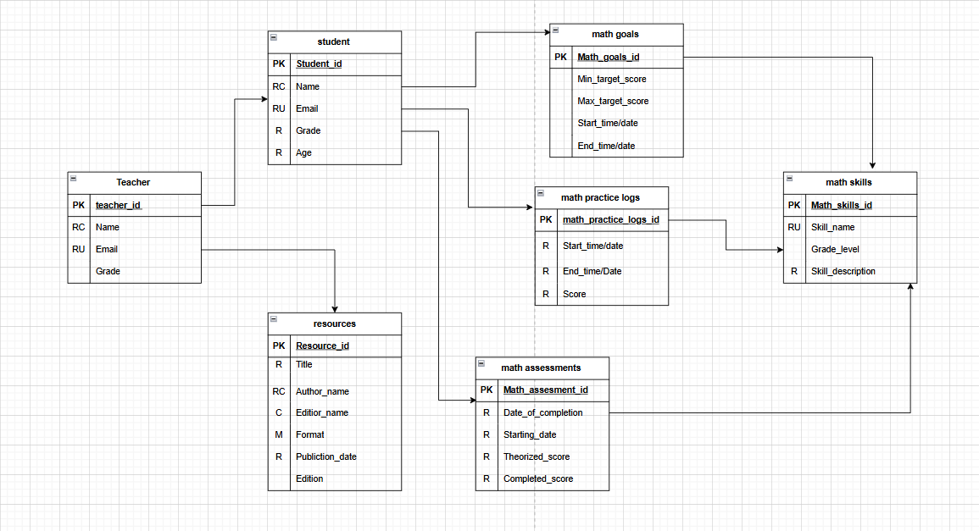

Logical Data Model Diagram.
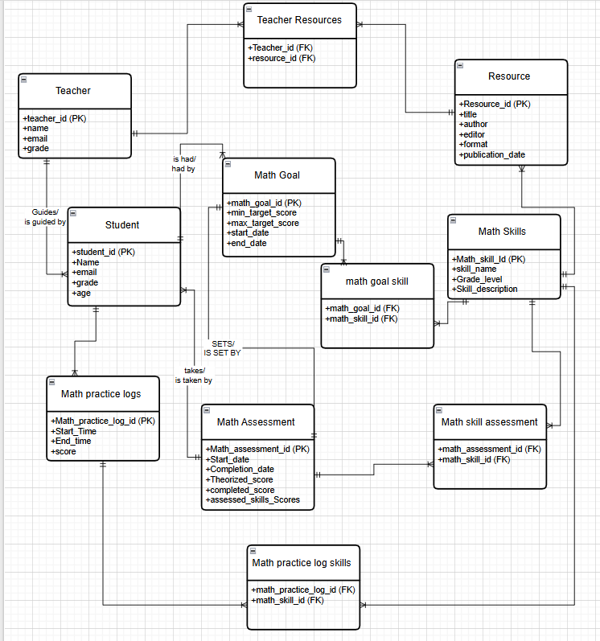

Identification of Your External Data Model and Data Logic.
The external data model for MINT delineates the user-facing perspective of the system, detailing how various stakeholders interact with the underlying data structures without exposing the internal implementation details. This model serves as the interface between the database and its end users, providing a structured view that supports task-specific workflows and decision-making.
Teacher Perspective:
Teachers have comprehensive access to their assigned students, associated math skills, practice logs, assessments, goals, and instructional resources. They can monitor student performance through aggregated views of practice logs and assessment results, assign and manage resources aligned with specific math skills, and set performance targets for individual students. For example, a teacher may set a minimum target score of 70 and a maximum target score of 90 for a fraction addition skill, and then compare the student’s actual assessment score of 82 against this target range. Teachers can also record theorized scores for assessments, which serve as benchmarks for expected performance.
Student Perspective:
Students interact with a tailored interface that allows them to track progress across multiple math skills. They can log practice sessions with start and end times, access recommended resources, and visualize goal attainment. For instance, a student practicing multiplication may log three sessions: 15 minutes with a score of 75, 20 minutes with a score of 80, and 10 minutes with a score of 85. The system can calculate the average practice score as (75 + 80 + 85)/3 = 80 and provide feedback on progress toward the target score set by the teacher.
Resource Perspective:
Resources serve as instructional support linked to specific math skills. Both teachers and students can view resource metadata, including title, author, format, publication date, and edition. This ensures alignment between instructional materials and the targeted skills.
Data Logic:
The data logic layer enforces the integrity, consistency, and utility of the data in the external model. Validation rules ensure that email addresses conform to proper syntax, grade levels remain within the K–12 range, and chronological integrity is maintained for practice logs and goals. Business rules and calculations include score aggregation, comparison against theorized or target scores, and dynamic computation of progress metrics. For example, if a student’s average score for practicing addition of fractions is 78 and the teacher’s target range is 70–90, the system recognizes that the student is meeting expectations. Access control rules enforce that students only see their own data, while teachers have access to all data for their assigned students. Resource allocation maintains referential integrity, linking resources to the relevant math skills without duplication or loss of context.
Overall, the external data model and data logic in MINT are designed to optimize usability, support individualized learning trajectories, and ensure rigorous data integrity. By combining structured views, calculation logic, and access controls, the system provides a robust platform for monitoring, analyzing, and enhancing student mathematical skill development.

Basic Layout of All Application Screens.
The MINT application is designed with a user-centered approach, emphasizing intuitive navigation, clear visual hierarchy, and streamlined workflows tailored to the needs of teachers and students. Each dashboard presents role-specific information and interactive elements while maintaining a consistent layout, color scheme, and labeling system across the application.
Teacher Dashboard
Teachers have comprehensive access to their assigned students, math skills, practice logs, assessments, goals, and instructional resources. The Teacher Dashboard is structured to support efficient monitoring, decision-making, and instructional planning:
- Header: Navigation menu with links to Dashboard, Students, Math Skills, Resources, Assessments, and Goals. Profile information and logout options are included.
- Main Area: Overview panels provide class performance metrics, recent student activity, upcoming assessments, and alerts for students performing below target scores. Aggregate visualizations of student progress allow teachers to quickly identify trends and gaps in learning.
- Sidebar/Quick Actions: Buttons for adding new students, creating assessments, assigning resources, and setting goals.
- Footer: System notifications, help links, and contact support.
For example, a teacher may set a minimum target score of 70 and a maximum target score of 90 for a fraction addition skill. If a student achieves a score of 82, the dashboard highlights that the student is within the target range, allowing teachers to focus attention on students outside expected performance bands. This aligns with best practices in formative assessment and personalized learning (Black & Wiliam, 1998).
Student Dashboard
The Student Dashboard provides an individualized, interactive view of progress, practice, and goal attainment, supporting self-regulated learning and engagement:
- Header: Navigation menu with links to My Practice, My Goals, Assessments, Resources, and Help, along with student profile information.
- Main Area:
  - Progress Overview: Visual representations (e.g., bar or line graphs) display mastery for each math skill. For instance, a student practicing multiplication might see recent scores of 78, 82, and 85 across three sessions, with an average of 80, allowing them to track improvement over time.
  - Practice Log Summary: Table or card view of recent practice sessions, including start/end times, scores, and targeted skills.
  - Upcoming Assessments: List of assigned assessments with deadlines and progress indicators.
- Interactive Widgets: Quick access buttons for logging new practice sessions, viewing assigned resources, and monitoring goal progress through progress bars relative to target scores.
- Sidebar/Quick Access: Notifications for incomplete practice sessions or upcoming assessments, tips for improving performance, and filters to view practice logs or resources by skill or date.
- Footer: Help links, system notifications, and motivational messages to encourage consistent engagement.
Role-based access ensures students see only their own data, while teachers retain full access to student performance for instructional oversight. The Student Dashboard’s design emphasizes immediate visual feedback, cognitive clarity, and actionable insights, supporting self-regulated learning consistent with research in educational psychology (Bandura, 1997; Shute, 2008).
Overall, the Teacher and Student Dashboards provide a consistent, intuitive interface that enhances usability, supports individualized learning trajectories, and enables efficient monitoring of student performance. The integration of visual analytics, interactive elements, and role-based access ensures that the MINT application aligns with best practices in educational technology design (Shneiderman et al., 2016; Pardo et al., 2019).

Diagram of Each Screen Used in the Application.

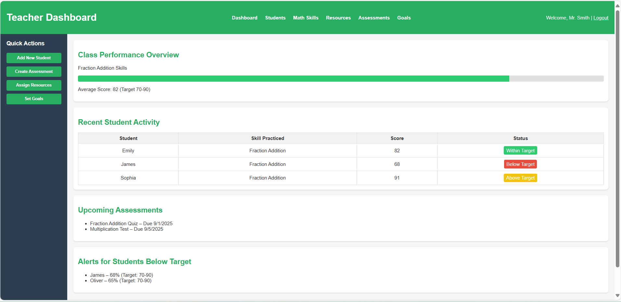

Teacher dashboard code:

<!DOCTYPE html>
<html lang="en">
<head>
<meta charset="UTF-8">
<meta name="viewport" content="width=device-width, initial-scale=1.0">
<title>Teacher Dashboard</title>
<style>
body {
font-family: Arial, sans-serif;
margin: 0;
background-color: #f4f6f8;
color: #333;
}

/* Header */
header {
background-color: #27ae60;
color: white;
padding: 15px 20px;
display: flex;
justify-content: space-between;
align-items: center;
}

header nav a {
color: white;
margin: 0 10px;
text-decoration: none;
font-weight: bold;
}

header nav a:hover {
text-decoration: underline;
}

/* Layout */
.container {
display: flex;
min-height: 90vh;
}

/* Sidebar */
.sidebar {
width: 220px;
background-color: #2c3e50;
color: white;
padding: 20px;
box-sizing: border-box;
}

.sidebar h3 {
margin-top: 0;
}

.sidebar button {
display: block;
width: 100%;
padding: 10px;
margin: 10px 0;
border: none;
border-radius: 4px;
background-color: #27ae60;
color: white;
font-weight: bold;
cursor: pointer;
}

.sidebar button:hover {
background-color: #1e8449;
}

/* Main content */
.main {
flex-grow: 1;
padding: 20px;
box-sizing: border-box;
}

h2 {
color: #27ae60;
}

.section {
background-color: white;
padding: 15px;
margin-bottom: 20px;
border-radius: 8px;
box-shadow: 0 2px 4px rgba(0,0,0,0.1);
}

/* Table styles */
table {
width: 100%;
border-collapse: collapse;
}

table th, table td {
border: 1px solid #ddd;
padding: 8px;
text-align: center;
}

table th {
background-color: #f2f2f2;
}

/* Alerts */
.alert-low {
background-color: #e74c3c;
color: white;
padding: 5px 8px;
border-radius: 4px;
display: inline-block;
}

.alert-ok {
background-color: #f1c40f;
color: white;
padding: 5px 8px;
border-radius: 4px;
display: inline-block;
}

.alert-good {
background-color: #2ecc71;
color: white;
padding: 5px 8px;
border-radius: 4px;
display: inline-block;
}

/* Footer */
footer {
background-color: #f2f2f2;
text-align: center;
padding: 15px;
font-size: 14px;
color: #555;
}

/* Progress bar */
.progress-bar {
background-color: #e0e0e0;
border-radius: 4px;
overflow: hidden;
height: 20px;
margin-top: 5px;
}

.progress-fill {
height: 100%;
width: 0;
transition: width 1s;
}

.progress-good { background-color: #2ecc71; }
.progress-ok { background-color: #f1c40f; }
.progress-low { background-color: #e74c3c; }

</style>
</head>
<body>

<header>
<div class="logo"><h1>Teacher Dashboard</h1></div>
<nav>
<a href="#">Dashboard</a>
<a href="#">Students</a>
<a href="#">Math Skills</a>
<a href="#">Resources</a>
<a href="#">Assessments</a>
<a href="#">Goals</a>
</nav>
<div class="profile">
<p>Welcome, Mr. Smith | <a href="#" style="color:white; text-decoration:underline;">Logout</a></p>
</div>
</header>

<div class="container">
<div class="sidebar">
<h3>Quick Actions</h3>
<button>Add New Student</button>
<button>Create Assessment</button>
<button>Assign Resources</button>
<button>Set Goals</button>
</div>

<div class="main">
<div class="section">
<h2>Class Performance Overview</h2>
<p>Fraction Addition Skills</p>
<div class="progress-bar">
<div class="progress-fill progress-good" style="width: 82%;"></div>
</div>
<p>Average Score: 82 (Target 70-90)</p>
</div>

<div class="section">
<h2>Recent Student Activity</h2>
<table>
<tr>
<th>Student</th>
<th>Skill Practiced</th>
<th>Score</th>
<th>Status</th>
</tr>
<tr>
<td>Emily</td>
<td>Fraction Addition</td>
<td>82</td>
<td><span class="alert-good">Within Target</span></td>
</tr>
<tr>
<td>James</td>
<td>Fraction Addition</td>
<td>68</td>
<td><span class="alert-low">Below Target</span></td>
</tr>
<tr>
<td>Sophia</td>
<td>Fraction Addition</td>
<td>91</td>
<td><span class="alert-ok">Above Target</span></td>
</tr>
</table>
</div>

<div class="section">
<h2>Upcoming Assessments</h2>
<ul>
<li>Fraction Addition Quiz – Due 9/1/2025</li>
<li>Multiplication Test – Due 9/5/2025</li>
</ul>
</div>

<div class="section">
<h2>Alerts for Students Below Target</h2>
<ul>
<li>James – 68% (Target: 70-90)</li>
<li>Oliver – 65% (Target: 70-90)</li>
</ul>
</div>
</div>
</div>

<footer>
<p>System notifications | Help | Contact Support</p>
</footer>

<script>
// Animate progress bars
window.onload = function() {
const fills = document.querySelectorAll('.progress-fill');
fills.forEach(fill => {
const width = fill.style.width;
fill.style.width = '0';
setTimeout(() => fill.style.width = width, 100);
});
};
</script>

</body>
</html>

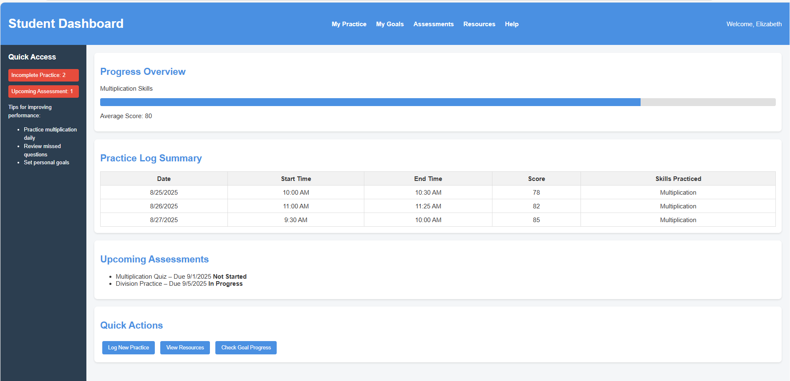
Student dashboard code:

!DOCTYPE html>
<html lang="en">
<head>
<meta charset="UTF-8">
<meta name="viewport" content="width=device-width, initial-scale=1.0">
<title>Student Dashboard</title>
<style>
body {
font-family: Arial, sans-serif;
margin: 0;
background-color: #f4f6f8;
color: #333;
}

/* Header */
header {
background-color: #4a90e2;
color: white;
padding: 15px 20px;
display: flex;
justify-content: space-between;
align-items: center;
}

header nav a {
color: white;
margin: 0 10px;
text-decoration: none;
font-weight: bold;
}

header nav a:hover {
text-decoration: underline;
}

/* Layout */
.container {
display: flex;
min-height: 90vh;
}

/* Sidebar */
.sidebar {
width: 220px;
background-color: #2c3e50;
color: white;
padding: 20px;
box-sizing: border-box;
}

.sidebar h3 {
margin-top: 0;
}

.sidebar p, .sidebar li {
font-size: 14px;
line-height: 1.5;
}

.sidebar .notification {
background-color: #e74c3c;
padding: 8px;
margin: 10px 0;
border-radius: 4px;
font-size: 14px;
}

/* Main content */
.main {
flex-grow: 1;
padding: 20px;
box-sizing: border-box;
}

h2 {
color: #4a90e2;
}

.section {
background-color: white;
padding: 15px;
margin-bottom: 20px;
border-radius: 8px;
box-shadow: 0 2px 4px rgba(0,0,0,0.1);
}

/* Table styles */
table {
width: 100%;
border-collapse: collapse;
}

table th, table td {
border: 1px solid #ddd;
padding: 8px;
text-align: center;
}

table th {
background-color: #f2f2f2;
}

/* Buttons */
.widget-button {
background-color: #4a90e2;
color: white;
border: none;
padding: 10px 15px;
margin: 5px;
border-radius: 4px;
cursor: pointer;
}

.widget-button:hover {
background-color: #357ab8;
}

/* Footer */
footer {
background-color: #f2f2f2;
text-align: center;
padding: 15px;
font-size: 14px;
color: #555;
}

/* Progress bar */
.progress-bar {
background-color: #e0e0e0;
border-radius: 4px;
overflow: hidden;
height: 20px;
margin-top: 5px;
}

.progress-fill {
background-color: #4a90e2;
height: 100%;
width: 0;
transition: width 1s;
}
</style>
</head>
<body>

<header>
<div class="logo"><h1>Student Dashboard</h1></div>
<nav>
<a href="#">My Practice</a>
<a href="#">My Goals</a>
<a href="#">Assessments</a>
<a href="#">Resources</a>
<a href="#">Help</a>
</nav>
<div class="profile">
<p>Welcome, Elizabeth</p>
</div>
</header>

<div class="container">
<div class="sidebar">
<h3>Quick Access</h3>
<div class="notification">Incomplete Practice: 2</div>
<div class="notification">Upcoming Assessment: 1</div>
<p>Tips for improving performance:</p>
<ul>
<li>Practice multiplication daily</li>
<li>Review missed questions</li>
<li>Set personal goals</li>
</ul>
</div>

<div class="main">
<div class="section">
<h2>Progress Overview</h2>
<p>Multiplication Skills</p>
<div class="progress-bar">
<div class="progress-fill" style="width: 80%;"></div>
</div>
<p>Average Score: 80</p>
</div>

<div class="section">
<h2>Practice Log Summary</h2>
<table>
<tr>
<th>Date</th>
<th>Start Time</th>
<th>End Time</th>
<th>Score</th>
<th>Skills Practiced</th>
</tr>
<tr>
<td>8/25/2025</td>
<td>10:00 AM</td>
<td>10:30 AM</td>
<td>78</td>
<td>Multiplication</td>
</tr>
<tr>
<td>8/26/2025</td>
<td>11:00 AM</td>
<td>11:25 AM</td>
<td>82</td>
<td>Multiplication</td>
</tr>
<tr>
<td>8/27/2025</td>
<td>9:30 AM</td>
<td>10:00 AM</td>
<td>85</td>
<td>Multiplication</td>
</tr>
</table>
</div>

<div class="section">
<h2>Upcoming Assessments</h2>
<ul>
<li>Multiplication Quiz – Due 9/1/2025 <strong>Not Started</strong></li>
<li>Division Practice – Due 9/5/2025 <strong>In Progress</strong></li>
</ul>
</div>

<div class="section">
<h2>Quick Actions</h2>
<button class="widget-button">Log New Practice</button>
<button class="widget-button">View Resources</button>
<button class="widget-button">Check Goal Progress</button>
</div>
</div>
</div>

<footer>
<p>Need help? Visit the Help section. Keep practicing to improve your scores!</p>
</footer>

<script>
// Animate progress bar
window.onload = function() {
const fills = document.querySelectorAll('.progress-fill');
fills.forEach(fill => {
const width = fill.style.width;
fill.style.width = '0';
setTimeout(() => fill.style.width = width, 100);
});
};
</script>

</body>
</html>

SQL Up/Down Script to Implement the Internal Model with Initial Data.
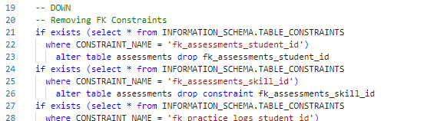
Please see full code in submitted work - Code starts on line 19 and runs through line 145. Snippet shown for ease of locating.

SQL Up/Down Script to Load/Migrate in Existing Data.

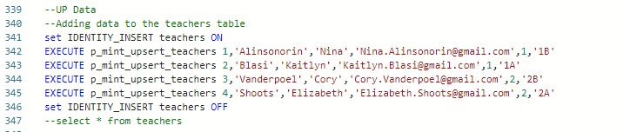
Please see full code in submitted work - Code starts on line 339 and runs through line 1708. Snippet shown for ease of locating.

Implementation of the Application.

Query 1
The school department is holding a reward ceremony at the end of the school year. Elizabeth Shoots wants to reward the three most approved students in the add_subtract_regroup_100 skill. Present the output of the student’s name, student’s skill, and the approvement scale.
--Query Answer 1
select
students.students_first_name
,students.students_last_name
,assessments.assessments_percent_correct
,assessments.assessments_raw_score
from students
left join assessments on students.students_student_id = assessments.assessments_student_id
left join math_skills on assessments.assessments_skill_id = math_skills.math_skills_skill_id
left join teachers on students.students_teacher_id = teachers.teachers_teacher_id
where math_skills.math_skills_name = 'Add_Subtract_Regroup_100' and teachers.teachers_last_name = 'Shoots'
order by assessments_percent_correct desc

Query 2
Cory Vanderpoel is worried about Payton Parker. The teacher wants to review the student’s skills and their performance. Present the student’s name, performance difference between theorized scores to the completed scores done by the student.
--Query Answer 2
select
students.students_first_name
,students.students_last_name
,math_skills.math_skills_name
,assessments.assessments_percent_correct
,assessments.assessments_raw_score
from students
left join assessments on students.students_student_id = assessments.assessments_student_id
left join math_skills on assessments.assessments_skill_id = math_skills.math_skills_skill_id
left join teachers on students.students_teacher_id = teachers.teachers_teacher_id
where students.students_last_name = 'Parker' and teachers.teachers_last_name = 'Vanderpoel'
order by assessments_percent_correct desc

Query 3
Nina Alinsonorin wants to determine which skill the students are most struggling in during the middle of Grade 1 semester. Present the skill, the assessment rate, and the practice log scores.
--Query Answer 3
select
students.students_first_name
,students.students_last_name
,math_skills.math_skills_name
,assessments.assessments_percent_correct
,assessments.assessments_raw_score
,AVG(practice_logs.practice_logs_practice_score) as avg_score
from students
left join assessments on students.students_student_id = assessments.assessments_student_id
left join math_skills on assessments.assessments_skill_id = math_skills.math_skills_skill_id
left join teachers on students.students_teacher_id = teachers.teachers_teacher_id
left join practice_logs on students.students_student_id = practice_logs.practice_logs_student_id
where teachers.teachers_last_name = 'Alinsonorin' and math_skills.math_skills_skill_id = 2
group by students.students_first_name
,students.students_last_name
,math_skills.math_skills_name
,assessments.assessments_percent_correct
,assessments.assessments_raw_score
order by assessments_percent_correct desc

Query 4
Kaitlyn Blasi wants to gather resources for the parents of Sage Harris. After a parent-teacher meeting, the parents are interested in the resources that can help their child’s math skills to grow. Gather a list of resources of the NumberSense_Operations skill with the format, title, and author.

--Query Answer 4
select *
from resources
where resources_skill_name = 'NumberSense_Operations'

Query 5
The district wants to recognize students who are most confident in their practice habits. Return each student’s name, the number of practice sessions completed, and their average practice log score.
--Query Answer 5
select
students.students_first_name
,students.students_last_name
,math_skills.math_skills_name
,AVG(practice_logs.practice_logs_practice_score) as avg_score
,count(1) as num_practices
from students
left join assessments on students.students_student_id = assessments.assessments_student_id
left join math_skills on assessments.assessments_skill_id = math_skills.math_skills_skill_id
left join practice_logs on students.students_student_id = practice_logs.practice_logs_student_id
group by students.students_first_name
,students.students_last_name
,math_skills.math_skills_name
order by avg_score desc

Query 6
The 2nd Grade teaching team wants to compare student progress against assessment expectations. List each math skill, the average theorized score, the average completed score, and whether students are meeting or falling below expectations.
--Query Answer 6
select
math_skills.math_skills_name
,avg(assessments.assessments_theorized_score) as avg_theory_score
,avg(assessments.assessments_raw_score) as avg_raw_score
,AVG(practice_logs.practice_logs_practice_score) as avg_pracice_score
from students
left join assessments on students.students_student_id = assessments.assessments_student_id
left join math_skills on assessments.assessments_skill_id = math_skills.math_skills_skill_id
left join practice_logs on students.students_student_id = practice_logs.practice_logs_student_id
left join teachers on teachers.teachers_teacher_id = students.students_teacher_id
where teachers_grade = 2
group by students.students_first_name
,students.students_last_name
,math_skills.math_skills_name
order by avg_theory_score desc

Query 7
Parents are curious about which grade levels spend the most time practicing math. Report the grade level, the average practice session length (end time- start time), and the maximum practice session length observed.
--Query Answer 7
select students.students_first_name
,students.students_last_name
,students.students_grade
,avg(practice_logs.practice_logs_start_time - practice_logs.practice_logs_end_time) as avg_practice_time
,max(practice_logs.practice_logs_start_time - practice_logs.practice_logs_end_time) as longest_session
from students
left join practice_logs on students.students_student_id = practice_logs.practice_logs_student_id
group by
students.students_last_name, students.students_grade
order by
4 desc

Reflections
Nina Ysabel Alinsonorin
For this project, I was responsible for creating Queries 5 through 7 as well as manually scraping the data needed for analysis. Working on these parts of the project gave me practice in both technical problem-solving and careful attention to data quality. Manually scraping the data pushed me to think critically about how the information was structured and how to format it consistently so it could fit into the database design. Writing the queries helped me consider how to frame questions in a way that produced clear and useful insights, while the process of preparing and organizing the data reinforced the importance of reliable structures to support accurate results. This experience also showed me the value of collaboration, since my work built on the models, diagrams, and coding done by my teammates. Overall, I came away with stronger SQL skills (thank you, Cory), more confidence in data preparation, and a better understanding of how each piece of a larger data science project connects together.

Kaitlyn Blasi
For the project, I contributed the entities and attributes chart, the organization of the document, the executive summary, and then the presentation. Through working on these sections, I was able to critically analyze the database but also the key aspects of the creation of it. I was able to gain experience in how to work with a team to complete a data science project, but also how to communicate what is needed in the project and what is left. I've only had experience with team projects through my library science courses, so being able to bridge my experience to data science has helped to give insight of the projects I wish to implement and explore in future library environments and how the projects could possibly be done. This team was an incredible mix of expertise and allowed us to showcase what we do best. My overall experience with this team and this project was a positive one and illustrated to me that I am in the right place.

Elizabeth Shoots
In our project, I was responsible for developing the logic model and conceptual model, designing the dashboard depictions, writing the supporting code, and creating the descriptions that explain its functionality. I also identified an external data model, mapped out the data logic, and worked on showing the relationships between the data elements. Through this work, I had the opportunity to strengthen my ability to think about data at both a high level and a technical level. Building the logic and conceptual models gave me practice in breaking down broad project goals into smaller, connected components. Creating the dashboards and code pushed me to think about usability and how to translate raw data into something visual and meaningful for an end user. Working with the external data model and data logic helped me see how different sources can be integrated and how important it is to clearly define relationships between datasets. Overall, my contributions gave me hands-on experience in connecting data design with real-world application, and I came away with a stronger understanding of how planning, modeling, and visualization all work together in a data science project.

Cory Vanderpoel
For this project, I was responsible for the SQL coding and ensuring the technical aspects of the design were implemented. I helped to format any data and did the ETLs to make the data available for processing. This has been a great re-learning experience as I let certain skills lapse. It would be great to expand this project into something more expansive and reliable for teachers. A tool of this nature could be quite useful. I look forward to taking my experience here and levering these skills to create a new tool for my department.

Team Log

Team Member | Responsible For…
Nina Ysabel Alinsonorin | - Queries 5 through 7  - Manual data scraping/data retrieval
Kaitlyn Blasi | - Executive Summary  - Entity and Attribute charts  - Queries 1 through 4  - Presentation
Elizabeth Shoots | - Logic model  - Conceptual model  - Dashboard depictions and code  - Dashboard descriptions  - Identification of External Data Model and Data Logic.  - Relationship between data identification
Cory Vanderpoel | - All SQL and technical coding.  - Adding to the final written assignment

References
Ali, A. (n.d.). How to create an admin dashboard in HTML and CSS. Medium. Retrieved August 15, 2025, from https://arhaanali.medium.com/how-to-create-an-admin-dashboard-in-html-and-css-a2a35ad31875
Bandura, A. (1997). Self-efficacy: The exercise of control. W. H. Freeman.
Black, P., & Wiliam, D. (1998). Assessment and classroom learning. Assessment in Education: Principles, Policy & Practice, 5(1), 7–74.
GeeksforGeeks. (n.d.). How to create responsive admin dashboard using HTML, CSS, JavaScript. GeeksforGeeks. Retrieved August 25, 2025, from https://www.geeksforgeeks.org/javascript/how-to-create-responsive-admin-dashboard-using-html-css-javascript/
Pardo, A., Han, F., & Ellis, R. A. (2019). Combining learning analytics and evidence-based interventions to enhance student learning. British Journal of Educational Technology, 50(6), 3059–3073.
SheCodes. (n.d.). How to code a user dashboard in HTML, CSS, and JavaScript. SheCodes. Retrieved August 28, 2025, from https://www.shecodes.io/athena/53680-how-to-code-a-user-dashboard-in-html-css-and-javascript
Shneiderman, B., Plaisant, C., Cohen, M., Jacobs, S., & Elmqvist, N. (2016). Designing the user interface: Strategies for effective human-computer interaction (6th ed.). Pearson.
Shute, V. J. (2008). Focus on formative feedback. Review of Educational Research, 78(1), 153–189.

